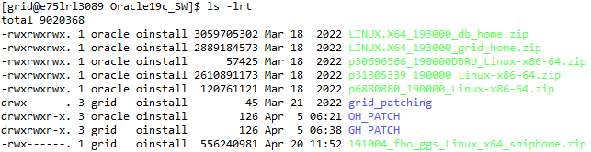

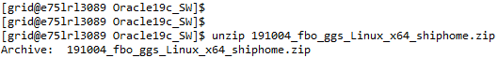
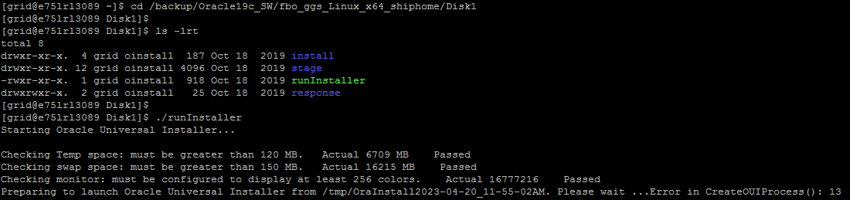
[grid@e75lrl3089 Disk1]$ mkdir -p /home/oracle/software_temp
[grid@e75lrl3089 Disk1]$ export TEMP=/home/oracle/software_temp

